Name: Zainab Azeem

Roll no: 21P-8025

Program: BCS

1. Write a Program to Calculate Permutation (nPr) for given values of n and r

The nPr (permutation) formula is:

n=int(input("enter num"))

r=int(input("enter num"))

sub=n-r

def fac(n):

i=1

fac=1

while i<=n:

fac=fac\*i

i+=1

return fac

num=fac(n)

denum=fac(sub)

permutation=num//denum

print(permutation)

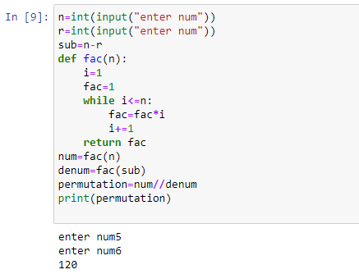

2- Write a program that accepts an integer and displays its factors. For example, if the

user enters 12, the program should display 2, 3, 4 and 6.

n=int(input("enter number:"))

for i in range(1,n):

if i!=1:

if n % i == 0:

print(i)

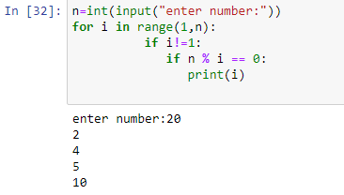

3- 3. Find the sum of the first 10 numbers that are divisible by 3 and 9.

sum=0

i=1

counter=0

while True:

i+=1

if i%3==0 and i%9==0:

sum=sum+i

counter=counter+1

if counter>=10:

break

print("sum of numbers",sum)

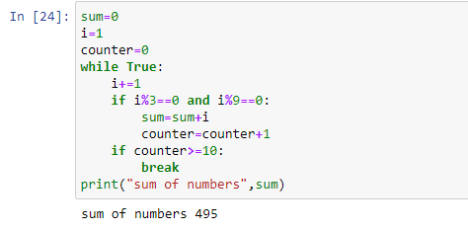

4-In Fibonacci series, every new term is generated by adding the previous two

terms as shown below. Write a program that displays Fibonacci series between 0 to

user input range.

n=int(input('how many terms?'))

n1=0

n2=1

for i in range(n):

print(n1)

nth=n1+n2

n1=n2

n2=nth

print()

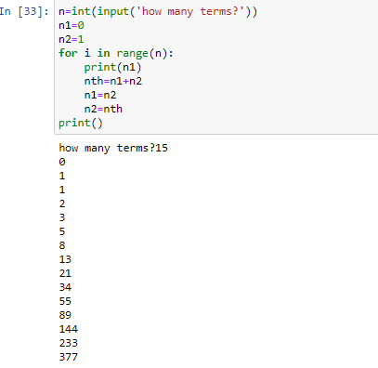

5-Write a program that performs a survey tally on beverages.

print("choose your following beverage from the following list.")

print("1.coffee 2.Tea 3.Coke 4.Orange juice ")

i=0

coffee=0

Tea=0

Coke=0

Orangejuice=0

num=int(input("enter number"))

for i in range(num):

n=int(input("Please enter favourite beverage"))

if n==-1:

break

else:

if n==1:

coffee=coffee+1

elif n==2:

Tea=Tea+1

elif n==3:

Coke=Coke+1

elif n==4:

Orangejuice+=Orangejuice+1

print("beverages Number of votes")

print("\*\*\*\*\*\*\*\*\*\*\*\*\*\*\*\*\*\*\*\*\*\*\*\*\*\*\*\*\*\*\*\*\*\*\*")

print("coffee", coffee)

print("Tea", Tea)

print("Coke", Coke)

print("Orange juice", Orangejuice)

